Lab
Batch Code : AND-D3393
Name : Vignesh S
ID : AF05054428
Topic : Create a Database & Table Using MySQL Command-Line Client

- Create a database with the name StudentManagementSystem.
mysql> create database student_management_system;
Query OK, 1 row affected (0.02 sec)
- Create a table with named Student with attributes
mysql> create table student(studentID int primary key,
-> first_name varchar(100),
-> last_name varchar(100),
-> dateofbirth date,
-> gender char(1),
-> email varchar(100),
-> phone varchar(100));
Query OK, 0 rows affected (0.05 sec)
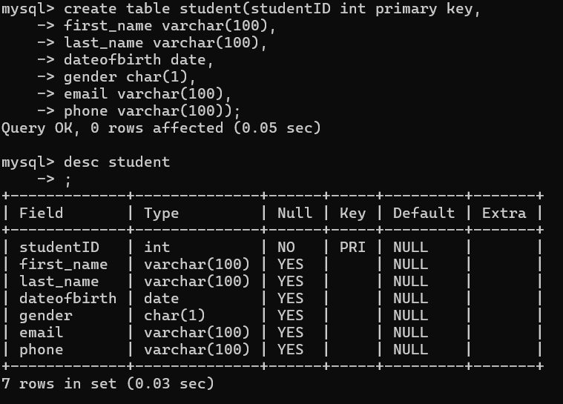

Create a table with name Course with attributes
mysql> create table course(courseID int primary key,
-> coursetitle varchar(100),
-> credits int);
Query OK, 0 rows affected (0.07 sec) 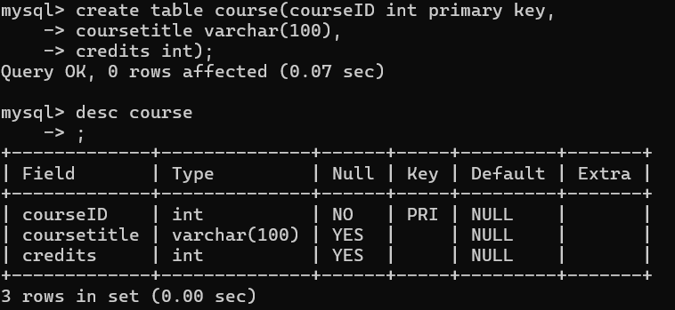
Create a table with named Instructor with attributes
mysql> create table instructor(instructorID int primary key,
-> firstname varchar(100),
-> lastname varchar(100),
-> email varchar(100));
Query OK, 0 rows affected (0.07 sec)
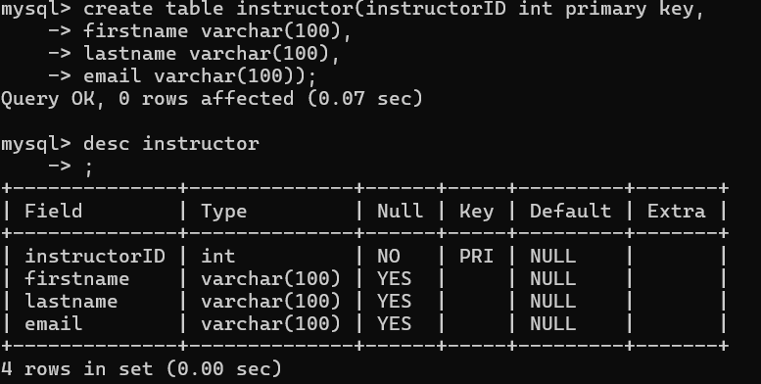

Create a table with named Enrollment with attributes
mysql> create table enrollment(enrollmentID int primary key,
-> enrollmentdate date,
-> studentID int,
-> courseID int,
-> instructorID int,
-> foreign key (studentID) references student ( studentID ),
-> foreign key (courseID) references course ( courseID ),
-> foreign key (instructorID) references instructor (instructorID));
Query OK, 0 rows affected (0.06 sec)
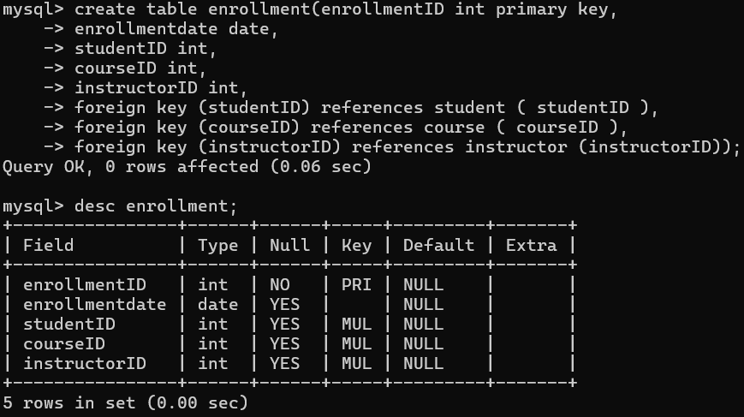

Create a table with named Score with attributes
mysql> create table score(scoreID int primary key,
-> courseID int,
-> studentID int,
-> dateofexam date,
-> creditobtained int,
-> foreign key (courseID) references course (courseID),
-> foreign key (studentID) references student (studentID));
Query OK, 0 rows affected (0.10 sec)
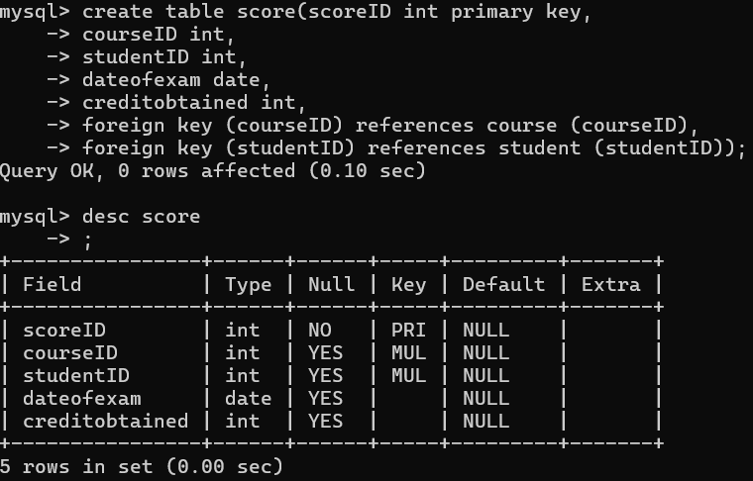

Create a table with named Feedback with attributes
mysql> create table feedback (feedbackID int primary key,
-> studentID int,
-> Date date,
-> instructorName varchar(100),
-> feedback varchar(100),
-> foreign key (studentID) references student (studentID));
Query OK, 0 rows affected (0.07 sec)
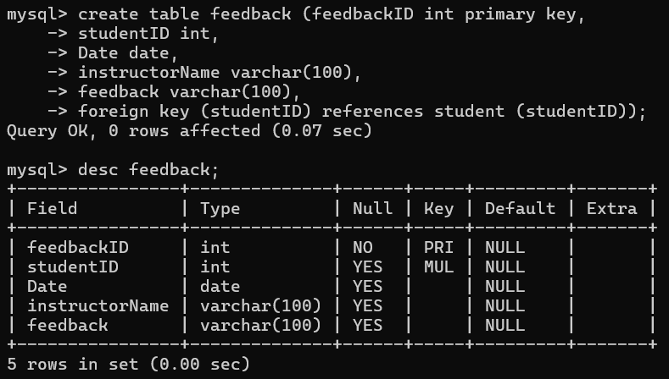

ER Diagram
